**HIGH LEVEL DESIGN (HLD)**

**AMAZON SALES DATA ANALYSIS**

**Priyanshu Dhunilal Gupta**

**Document Version Control**

|  |  |  |  |
| --- | --- | --- | --- |
| **Date Issued** | **Version** | **Description** | **Author** |
| 04th Aug 2023 | 1.0 | First Version Of complete HLD | Priyanshu Gupta |
|  |  |  |  |
|  |  |  |  |
|  |  |  |  |
|  |  |  |  |
|  |  |  |  |
|  |  |  |  |

**Contents**

Document Version Control……………………………………………………………………………………………………2

Abstract....................................................................................................................................4

1 Introduction ..........................................................................................................................5

1.1 Why this High-Level Design Document?...........................................................................5

1.2 Scope ................................................................................................................................6

2 General Description .............................................................................................................6

2.1 Product Perspective & Problem Statement .......................................................................6

Housing prices are an important reflection of the economy, and housing price ranges are of

great interest for both buyers and sellers. In this project, house prices will be predicted given

explanatory variables that cover many aspects of residential houses.....................................6

2.2 Tools used..........................................................................................................................6

3 Design Details.......................................................................................................................7

3.1 Functional Architecture .....................................................................................................7

4 KPIs.......................................................................................................................................8

4.1 KPIs (Key Performance Indicators) ...................................................................................8

5 Deployment...........................................................................................................................8

**­­**

**Abstract**

The Amazon Sales Analysis Project aims to provide insights and valuable Knowledge to understand sales performance on the Amazon platform.

Sales management of amazon has gained importance to meet increasing competition and the need for improved methods of distribution to reduce cost and to increase profits. Sales

management today is the most important function in a commercial and business enterprise.

Find key metrics and factors and show the meaningful relationships between attributes.This High-Level Design (HLD) document outlines the key components and functionalities of the proposed system.

1. **Introduction** 
   1. **Why this High level Design Document ?**

The purpose of this High-Level Design (HLD) Document is to add the necessary detail to the

current project description to represent a suitable model for coding. This document is also

intended to help detect contradictions prior to coding, and can be used as a reference manual for how the modules interact at a high level.

The HLD will:

1. Present all the design and aspects and define them in detail
2. Describe the user interface being implemented
3. Describe the hardware and software interfaces
4. Describe the performance requirements
5. Include design features and the architecture of the project
   1. **Scope**

The HLD documentation presents the structure of the system, such as the database

architecture, application architecture (layers), application flow (Navigation), and technology architecture. The HLD uses non-technical to mildly-technical terms which should be understandable to the administrators of the system.

1. **General Description** 
   1. **Product Perspective & Problem Statement**

Sales management of amazon has gained importance to meet increasing competition and the need for improved methods of distribution to reduce cost and to increase profits. Sales

management today is the most important function in a commercial and business enterprise.

The objective of the project perform data visualization techniques to understand the insight of the data.

* 1. **Tools Used**

Business Intelligence tools and liberary work such as numpy , Pandas ,Jupyter Notebook , Power BI





1. **Design Details** 
   1. **Functional Architecture**

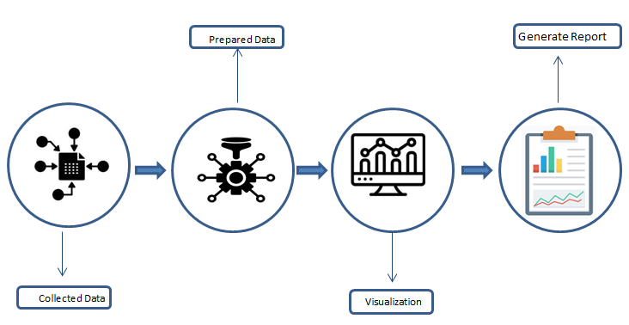

**Functional Architecture of Power BI**



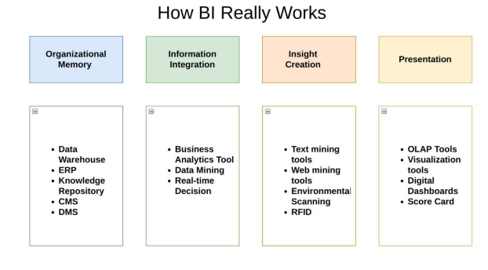

1. **KPIs (Key Performance Indicators)**

Dashboards will be implemented to display and indicate certain KPIs and relevant indicators

for Sales.And the dashboards will be included to display charts over time with progress on various indicators or factors

**4.1 KPIs (Key Performance Indicators)**

Key indicators displaying a summary of the Amazon Sales and its relationship with different

metrics

1. Total Revenue

2. Total Profit

3. Total Cost Amount

4. Total Number of Ordered Product

* 1. **Charts**

Chart Displaying a understanding of Amazon Sales Data

1. Yearly Revenue Trend – Line Chart
2. Top Product by Sales - Bar Chart
3. Revenue of Per Year - Pie Chart
4. Margin Amount by Year And Month – Line Chart
5. Top Product By Highest Profit Margin – Steps Chart
6. Loss Giving Product – Double Line In Single Chart
7. **Deployment**

Prioritizing data and analytics couldn’t come at a better time. Your company, no matter what

size, is already collecting data and most likely analyzing just a portion of it to solve business

problems, gain competitive advantages, and drive enterprise transformation. With the

explosive growth of enterprise data, database technologies, and the high demand for

analytical skills, today’s most effective IT organizations have shifted their focus to enabling

self-service by deploying and operating Power BI at scale, as well as organizing, orchestrating, and unifying disparate sources of data for business users and experts alike to author and consume content

Amazon E-Commerse Sales data is been cleaned using ETL tool Power Query and

analyzed on Power BI which will provide a better key insight for the data and tell you

a better story of the raw data. The Power BI report is published on workspace where

you can play with the data for necessary insights.